Principles of the Dilution Wash Process
Tommy Rohmann, 2026

Background

Clothing Volume
For a clothing item, it may be difficult to define its volume. Textiles are by in large a 2D face stitched together to make a 3D shape. Fabric is compliant, compressible, and permeable. To circumvent complications in measuring volume, multiple values of clothing volume can be used. For the use of a compression washing machine, some pertinent forms of volume are defined below:

$V_{T}$: True Volume, The liquid volume the clothing item displaces.
$V_{C}$: Compressed Volume, Space taken by clothing item when compressed to maximum.
$D$: Dead Volume, Liquid that cannot be extracted from a clothing item through compression.
$V_{H}$: Heap Volume: Space taken up by clothing item packed into a shape uncompressed. Minimal force of clothing acting on chamber walls. Convenient chamber volume for a user to place clothing in wash chamber.

Determining Volume for a Given Clothing Item
For the most part, clothing volume can be determined by putting a clothing item into a given space and measuring the volume of the space occupied. Fluid volume in a container before and after having a clothing item submerged and saturated can be used to find true volume. The dead volume can be found using other known volumes. If the compressed volume is known, and there is a known true volume, then the dead volume is the remaining volume not occupied by the clothing item.
$$D=V_{C}-V_{T}$$

The dead volume can also be found by taking a known volume of water a clothing item is submerged in and finding how much is extracted through compression. The difference is the dead volume.

Dilution Cleaning

Process Overview
When a dirty clothing item is placed in the wash chamber, it has a specific quantity of contaminants. When water is introduced into the clothing item, the contaminants dissolve and diffuse throughout the solution. Of the total volume of water currently in the chamber, a portion will be removed, while the other is unrecoverable as dead volume. The ratio between the total volume of water in the chamber and a given proportion of water yields the total proportion of contaminants in that portion of water.

Basic Illustration of Contaminant Removal Through Dilution
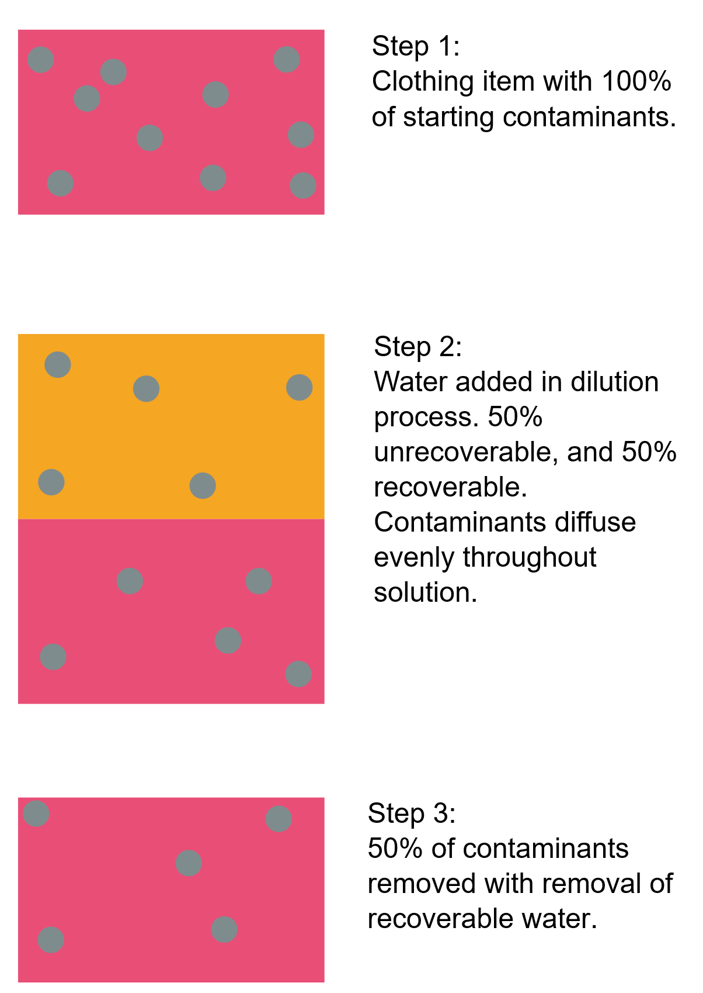

From here the water is removed, taking with it the contaminants in the solution, leaving behind a lower quantity of contaminants than before. Subsequent repetitions of this cycle remove portions of the contaminants in the same manner.

Wash Volume Ratio Optimization by Studying Removed Contaminants
Consider a wash chamber filled with water. When the dirty water is removed from the wash chamber some of the liquid is left behind in the chamber and cannot be recovered, called the dead volume, $D$. With an assumed homogeneous mixture of contaminants in the wash water, the proportion of contaminants remaining in the clothing item is equal to the ratio between the total water in the chamber and the dead volume.

In a water-scarce environment, there may be a total water allotment for a given clothing item. While the dilution process using all the water at once does clean the clothing item, the clothing item can be made cleaner by executing two dilution cycles each using half the allotted water. The example below has a proportion of two parts recoverable water to unrecoverable water:
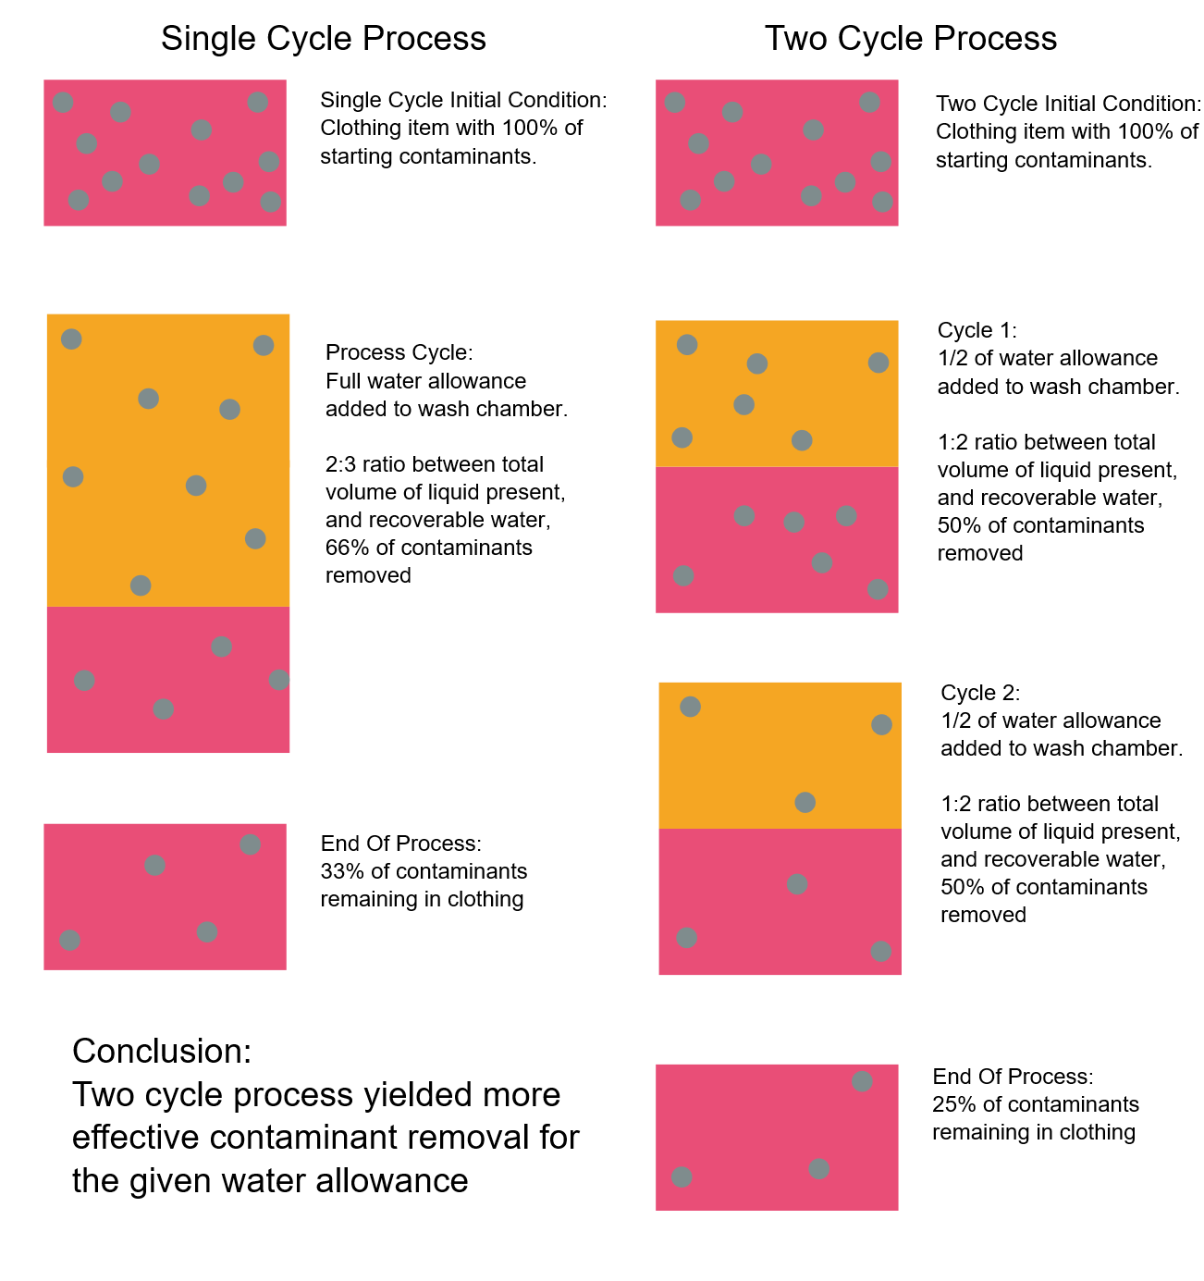
With a smaller quantity used per cycle being more effective, this leaves the question, is there a ratio of added volume to dead volume which optimizes the use of water to remove contaminants? From the relationship for contaminant removal defined earlier, the following equation can be used to describe the amount of contaminant removed by a volume, $V$, of water for a given dilution process.
$$R=C\frac{V}{D+V}$$
The concentration of contaminants removed can be defined as the volume removed divided by the volume removed during the process.
$$k=\frac{R}{V}$$
By dividing both sides of the equation by $V$, the concentration being removed after a cleaning cycle can be found. Since the goal is to maximize the concentration for a given amount of wash water used, the maximum value of this function reveals the optimal proportion of dead volume to wash water to use.
$$C\frac{1}{D+V}=\frac{R}{V}=k$$
Just from looking at the function, the lower the volume added, the higher the concentration of contaminants is removed. Intuitively this result makes sense. As more water is added to the chamber, the mixture is further diluted, which will inherently decrease the concentration of contaminants in the water.

Limits to Cleaning Potential for Dilution Cleaning
The previous section revealed that a process utilizing many smaller dilution cycles results in a more efficient use of water. This still leaves a question, what is the cleanest a clothing item can get for a given amount of water used? If an infinite number of cycles using an infinitesimally small amount of water is used for a wash process, how clean can a clothing item get for a given water consumption?

To answer this question, the dilution relationship can be used to define the amount of contaminants remaining in the clothing item after a given wash process. $C_{0}$ represents the number or percentage of contaminants in a clothing item prior to the process, and $C_{1}$ represents the contaminants remaining in the clothing item in the wash chamber after the process.
$$C_{0}\frac{D}{D+V}=C_{1}$$

For subsequent cycles, the same proportion applies, but the quantity of contaminants after the process is now the starting quantity for the next process.
$$C_{0}\frac{D}{D+V}=C_{1}, C_{1}\frac{D}{D+V}=C_{2}, …, C_{n-1}\frac{D}{D+V}=C_{n}$$
By substituting the equation for $C_{1}$ in for the cycle yielding $C_{2}$, the following equation yields the resulting contaminants remaining in the clothing item after two cycles.
$$C_{0}\left(\frac{D}{D+V}\right)\left(\frac{D}{D+V}\right)=C_{2}$$
This can be continued for processes with more cycles indefinitely. Since for this analysis, the volume of wash water used per cycle will become infinitesimally small, the volume of the water used in each cycle can be assumed to be equal with minimal consequence. From this, the total contaminants remaining in a clothing item after $n$ wash processes can be written as:
$$C_{n}=C_{0}{\left(\frac{D}{V+D}\right)}^{n}$$

In this equation, an ever greater amount of water is used with more wash cycles, but the goal is to find the best contaminant removal for a given amount of water. To account for this, the volume $V$ can be divided equally between each of the $n$ cycles. In this equation, $V$ now refers to the total water allotment for a given wash process:
$$C_{n}=C_{0}{\left(\frac{D}{\frac{V}{n}+D}\right)}^{n}$$
The function can be simplified and turned into a form more useful for further analysis. Both the numerator and denominator of the portion of the function are divided by $D$,
and $a^{n}={\left(\frac{1}{a}\right)}^{-n}$ is used to flip the numerator and denominator, yielding the simplified function:
$${C_{n}=C}_{0}{\left(1+\frac{V}{nD}\right)}^{-n}$$
Now, for a given an allotted volume of wash water, $V$, taking the limit of the function as the number of cycles, $n$, approaches infinity will yield the fewest contaminants remaining in the clothing item for this process.
$$\lim_{n→∞}{C_{0}\left(1+\frac{V}{nD}\right)}^{-n}$$
This equation is a variation of the definition of Euler’s Number, $e$.
$$\lim_{n→∞}{{\left(1+\frac{a}{n}\right)}^{n}}=e^{a}$$
From the definition, the maximum cleaning potential for a given dead volume and a given allotment of wash water can be defined as:
$$\lim_{n→∞}{C_{0}\left(1+\frac{V}{nD}\right)}^{-n}=C_{0}e^{-\frac{V}{D}}$$

Comparison of Cleaning Potential Between Best and Worst Dilution Processes
Now that the best possible cleaning can be found, how much better is this method than to use all of the available wash water at once? Is this process more or less effective for certain quantities of water used?

The difference between a wash process with one cycle and a wash process with infinite cycles reveals how much better the infinite cycle process is than a single cycle for a given volume.
$$f(V)=C_{0}\left(\frac{D}{D+V}-e^{-\frac{V}{D}}\right)$$
This function is not linear. Although it is always more effective to wash by many small cycles for a given water allotment, at a certain ratio of dead volume to process water allotment, the advantage from having many cycles begins to diminish. By finding the maximum value of this function, this most effective ratio can be found. This is done by taking the derivative of the function, and finding its zero point.
$$C_{0}\left(\frac{e^{-\frac{V}{D}}}{D}-\frac{D}{{\left(V+D\right)}^{2}}\right)$$

This does not mean that this volume ratio yields the greatest cleaning potential. A clothing item can be made to be cleaner by using more water, however past this volume ratio, the efficiency of doing multiple wash cycles as opposed to a larger cycle gets to be more and more similar. This most effective ratio is approximately 2.51 parts dilution input volume to dead volume, achieving a 8.12% of original contaminants remaining in the clothing item.

This analysis can also be used to evaluate the relative effectiveness of any two wash processes of cycle number n, a more general formula for cleanliness comparison would be as follows:
$$C_{0}\left({\left(1+\frac{V}{n_{0}D}\right)}^{-n_{0}}-{\left(1+\frac{V}{n_{1}D}\right)}^{-n_{1}}\right)$$

Practical Cycle Count and Water Allotment Calculation
In a practical situation, there is no way to have a cycle which inputs, mixes, and removes an infinitesimally small amount of water, and there is not infinite time to perform an infinite number of cycles. This analysis does however help inform how many cycles may be economical to perform in a wash process. If a goal is to clean clothing to a certain benchmark, a plan for water allotment and cycle count can be used to find an efficient and effective wash process. This relationship can be described as:
$$100\%*\frac{C_{n}-C_{∞}}{C_{0}}$$

It is also important to note that in previous sections, the true consumption of water has not been defined. For a clothing item being inserted into a wash chamber, no water is present. While V describes the water used for dilution, the portion making up the dead volume also needs to be put into the system.
$$A=V+D$$
or
$$V=A-D$$
Where $A$ is the total allotted water for a given wash process.

As an example, for a T-Shirt with a dead volume of 150 mL, to wash with the optimal water allotment, 526.5 mL is required at peak economy.
$$A=V+D=D+Da=D(a+1)$$
$$150mL+150mL*2.51$$
$$=526.5mL$$

Possible Dilution Process Limitations
This procedure assumes that contaminants present in a given mixture are dissolvable in the wash medium used. If a clothing item contains non-dissolvable contaminants that are either liquid or solid, other wash process could be employed instead of or in conjunction with the dilution wash process to ensure optimal cleaning. This might include cycling water over a loosely packed clothing item to dislodge solid contaminants, filtering, and then recycling the wash water.

For dissolvable contaminants however, there are still limitations to this process. If the concentration of dissolvable contaminants is somehow great enough, it is possible that not all contaminants can dissolve into the wash water and no longer be a homogeneous mixture. This would reduce the effectiveness of the process, though optimal cleaning would still be possible with the use of more water or other means.

Conclusions to Draw from Analysis
Understanding the relationship between cycle count, water allotment, and dead volume for a washing process can inform, and be used to greatly reduce water consumption for a desired level of cleanliness.

One such example could be to inform certain design features of a given washing machine. Washing machines require the use of pumps and piping to move water from location to location and facilitate the wash process. While a clothing item has a specific dead volume, the volume of piping also contributes to the dead volume seen by the process. By this analysis, for dilution cleaning, a washing machine should be optimized to reduce the dead volume associated with the use of such pipes and other fluid management components.

Another example of use of this analysis could be to optimize a given wash process for a certain washing machine and clothing item. Analysis could find ways to reduce process time, power consumption, and water usage for a washing machine by determining the dead volume in the beginning of the wash process, and then updating the wash instructions to use a corresponding quantity of water.

